|  |
| --- |
| **St Alban’s CofE Primary School**  **Science End of Year** |

At the end of year, I will know and remember…

Working Scientifically

* How to observe closely.
* How to compare and group things.
* Ask scientific questions.

Animals, including Humans

* Animals have babies that grow into adults. E.g. pig – piglet, cow – calf, elephant - calf.
* Animals need food, water and air to keep healthy and stay alive.
* Humans need to eat a healthy diet and exercise to stay fit and healthy.

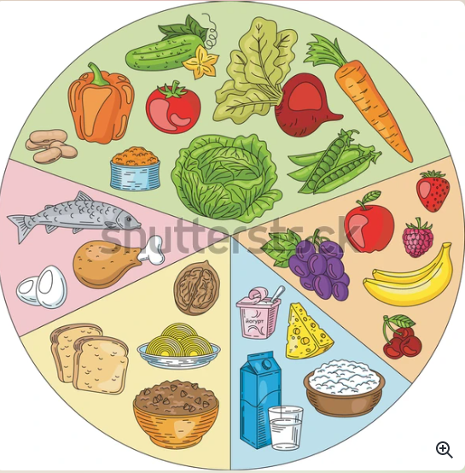

Materials

* Materials change shape by bending, squashing, twisting, pulling, and stretching.
* Glass is used for windows so you can see through it.
* Wood is used for doors so it is sturdy.
* Fabric is used for clothes so it is soft.

Living things in their habitats

* A table is dead, a dog is alive, glass have never been alive.
* Living, non- living, never been alive.
* Animals get their food from plants and other animals.
* What a food chain is.
* What a habitat is and can name where a fox, a woodlouse and a lion lives.

Plants

* Plants need water, sunlight and a warm temperature to grow.
* The life cycle of a plant – seed, shoot, stem. leaves and bud, flower
* 